PROBLEM 4 – Python

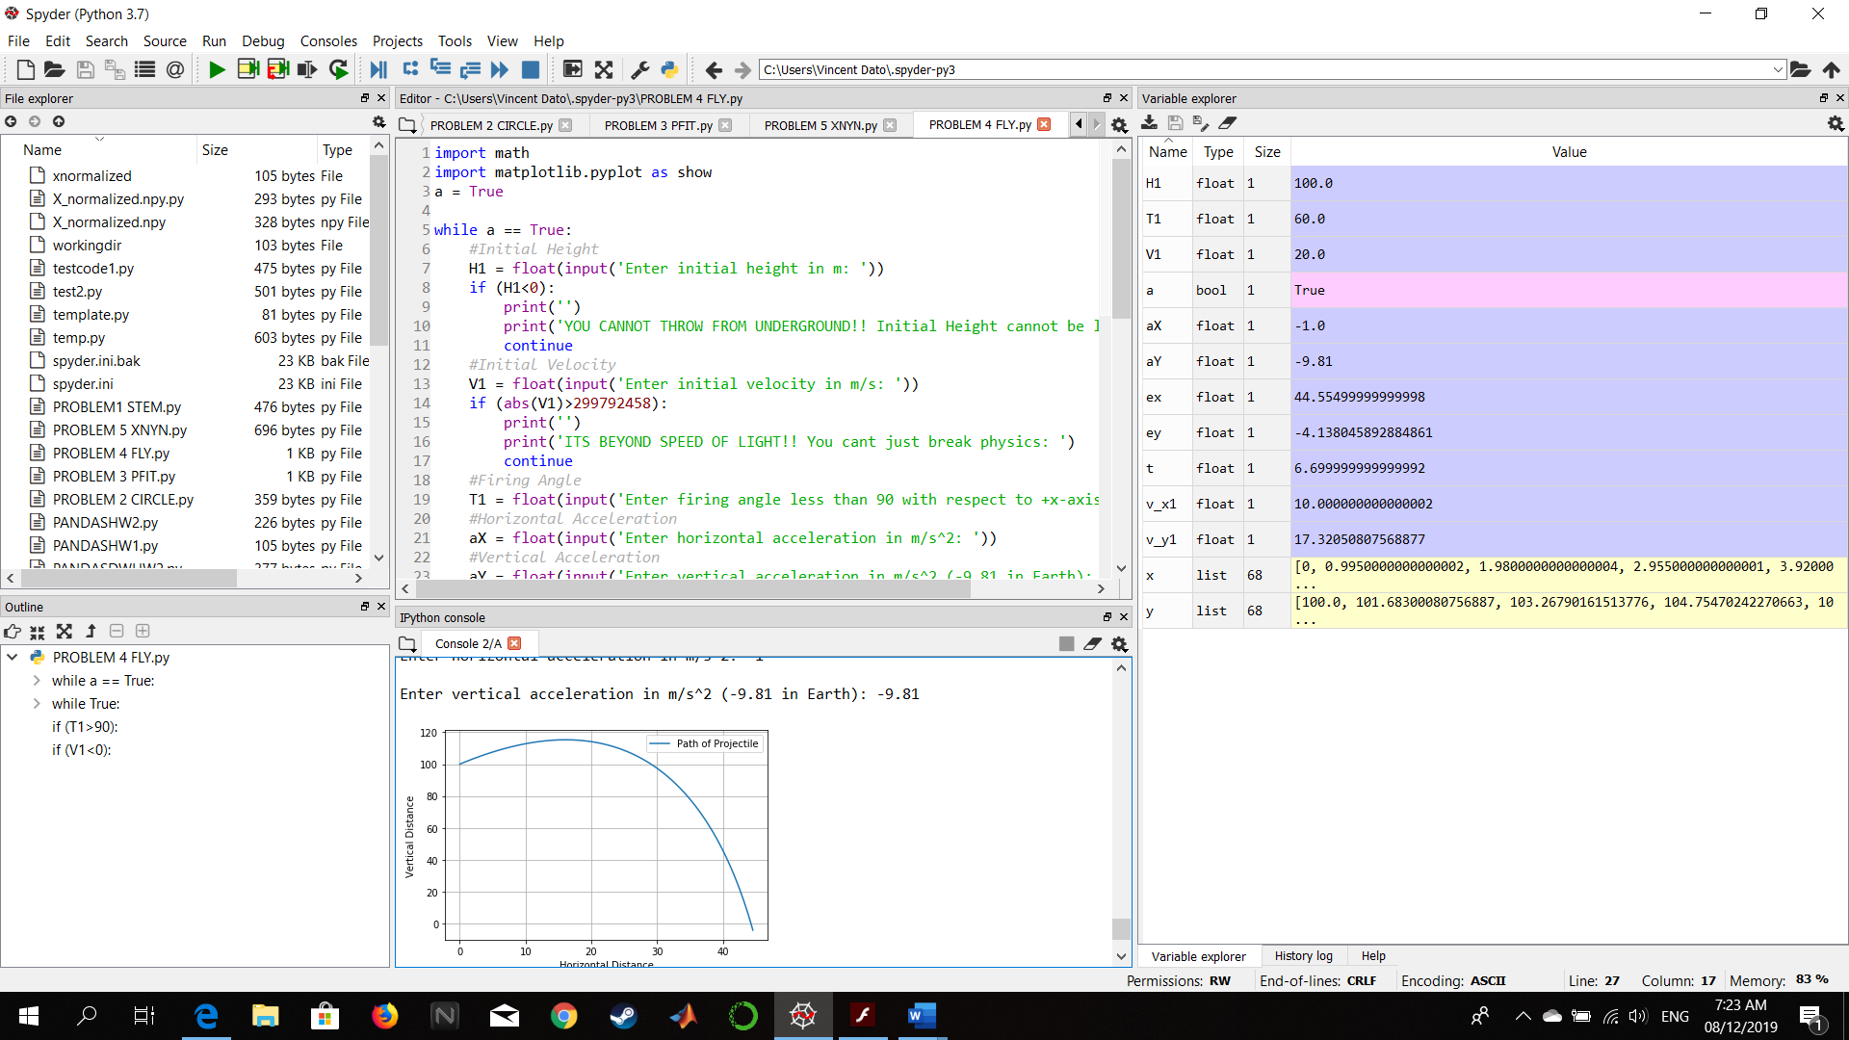

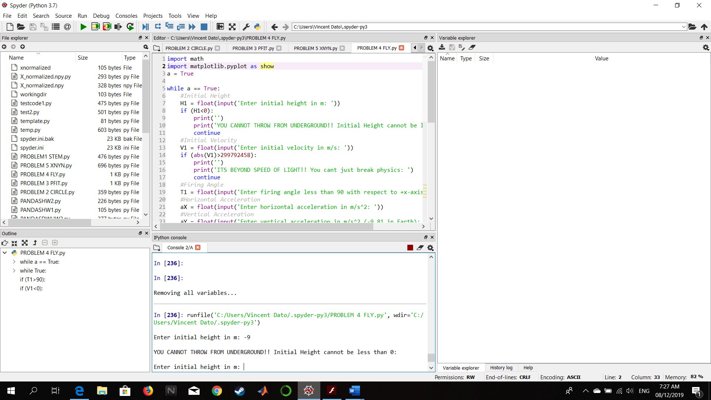Figure : Successful output with inputs 100 as initial height, 20 as initial velocity, 60 degrees as firing angle, -1 as horizontal acceleration, and -9,81 as vertical acceleration

Figure :Error if initial height is negative or below ground

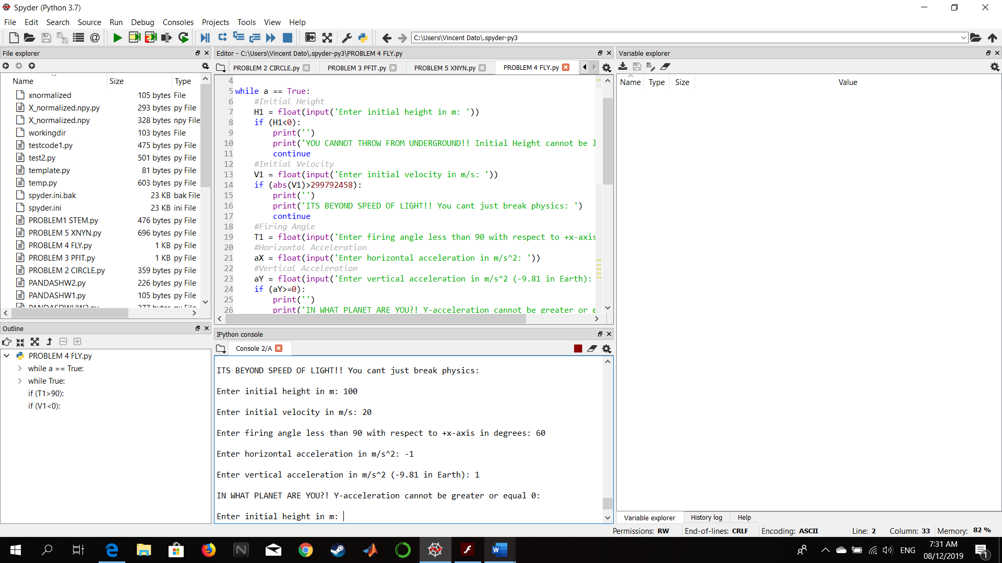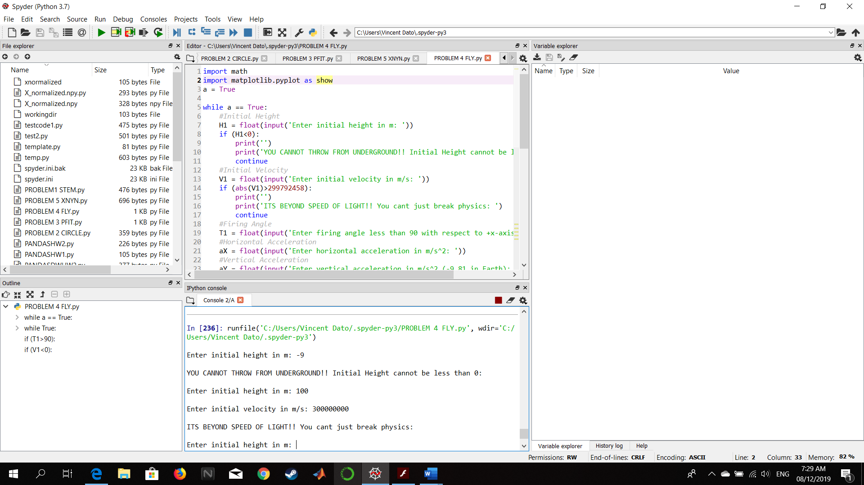

Figure :Error if vertical acceleration is greater or equal to 0

Figure : Error if initial velocity is beyond speed of light

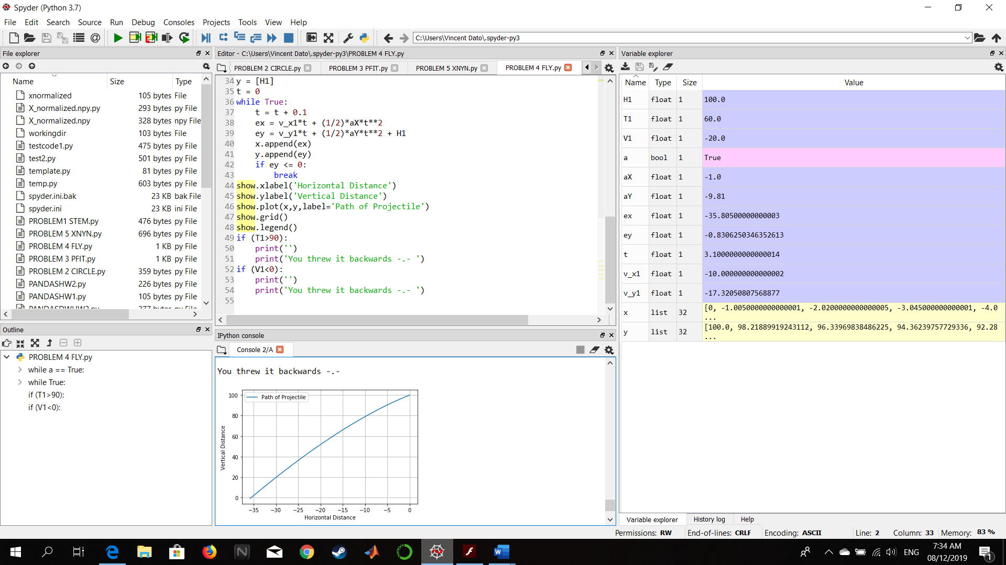

Figure :Output plot if either initial velocity is negative or firing angle is greater than 90 or less than -90